**GOVERNMENT ARTS COLLEGE,OOTY**

**DEPARTMENT OF MATHEMATICS**

**Mentor :** Mrs. Indrani J.B

**Team leader :** Aiswarya .R

**Team member 1 :** Arthi priya.S

**Team member 2 :** Sanmugam .R

**Team member 3 :**Aagarshika R.A

**UNLOCKING INSIGHTS INTO THE GLOBAL AIR TRANSPORTATION**

1. **INTRODUCTION :**
   1. **OVERVIEW :**

*Air transportation plays a pivotal role in connecting people and goods across the globe. It encompasses a vast network of airlines, airports, and support services that ensure the safe and efficient movement of passengers and cargo. From commercial airlines offering domestic and international flights to cargo carriers transporting goods, air transportation is characterized by its speed, convenience, and global reach. It’s a crucial driver of economic growth, tourism, and international trade, making it an indispensable component of modern global connectivity. However, it also faces challenges related to environmental sustainability, infrastructure development, and safety, which require ongoing attention and innovation to ensure its continued success.*

* 1. **PURPOSE :**

***Air transportation serves several purposes, including:***

***Passenger Travel:*** *Airplanes are a fast and efficient means of transporting people over long distances, both domestically and internationally, for business, leisure, and other purposes.*

***Cargo Transport:*** *Air cargo plays a crucial role in global trade, allowing for the rapid movement of goods, including perishable items and high-value products.*

***Emergency Services:*** *Air transportation is vital for emergency medical evacuations, disaster relief efforts, and search and rescue missions.*

***Tourism:*** *Air travel supports the tourism industry by connecting travelers to popular destinations worldwide.*

***Business and Commerce:*** *Many businesses rely on air transportation to facilitate global trade, attend meetings, and transport employees.*

***Military and Defense:*** *Air transport is a critical component of military operations for troop deployment, supply delivery, and reconnaissance.*

***Humanitarian Aid****: Airplanes are used to deliver humanitarian aid to areas in need during crises or disasters.*

***Research and Exploration:*** *Aircraft are employed in scientific research, environmental monitoring, and exploration of remote regions.*

***Connectivity:*** *Airports serve as transportation hubs, connecting regions and facilitating economic development.*

***Space Exploration:*** *Airports and air transport are integral to launching and recovering spacecraft and equipment for space exploration.*

***These are just a few of the many purposes served by air transportation, highlighting its versatility and importance in today’s interconnected world.***

**2.PROBLEM DEFINING & DESING THINKING**

**2.1 EMPATHY MAP :**

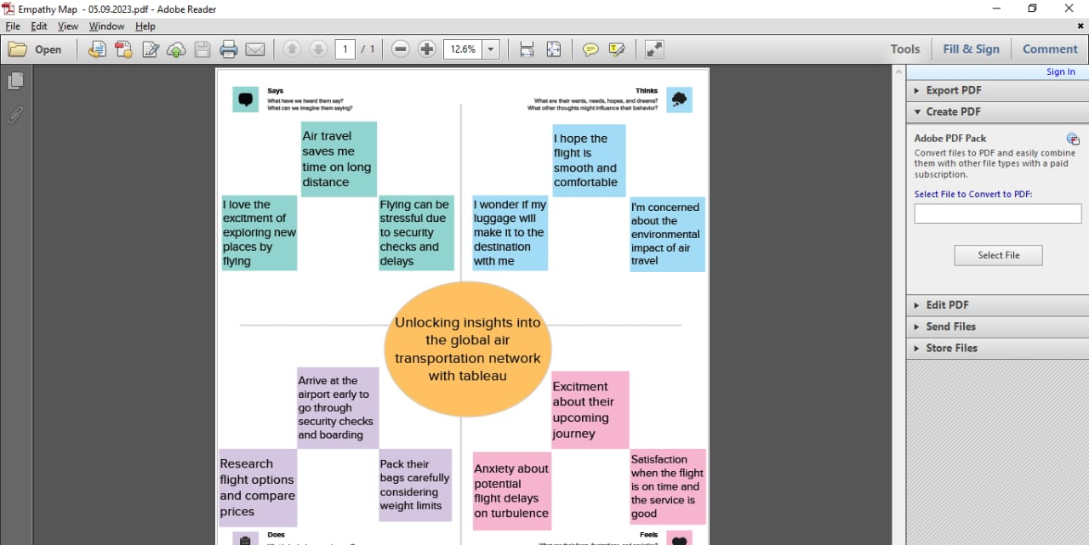

**2.2 IDEATION AND BRAINSTORMING MAP**

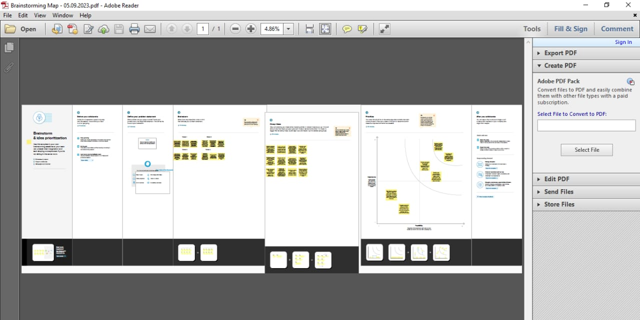

**3.RESULT**

**DASHBOARD**

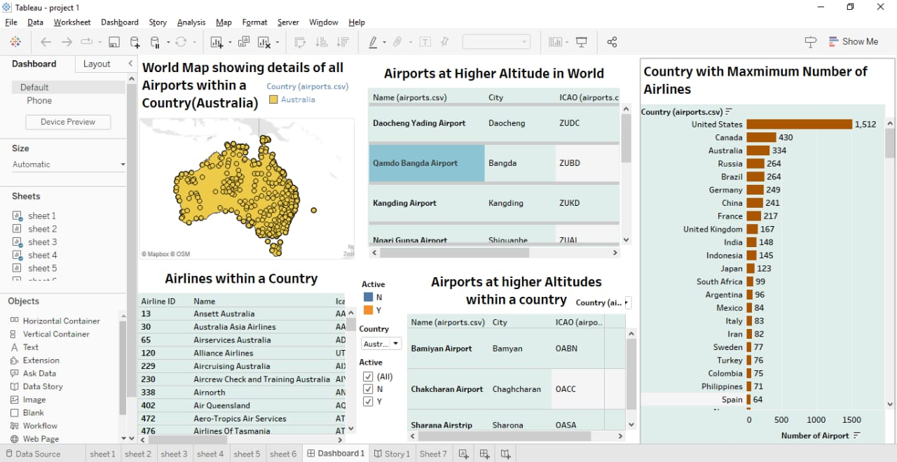**1.**

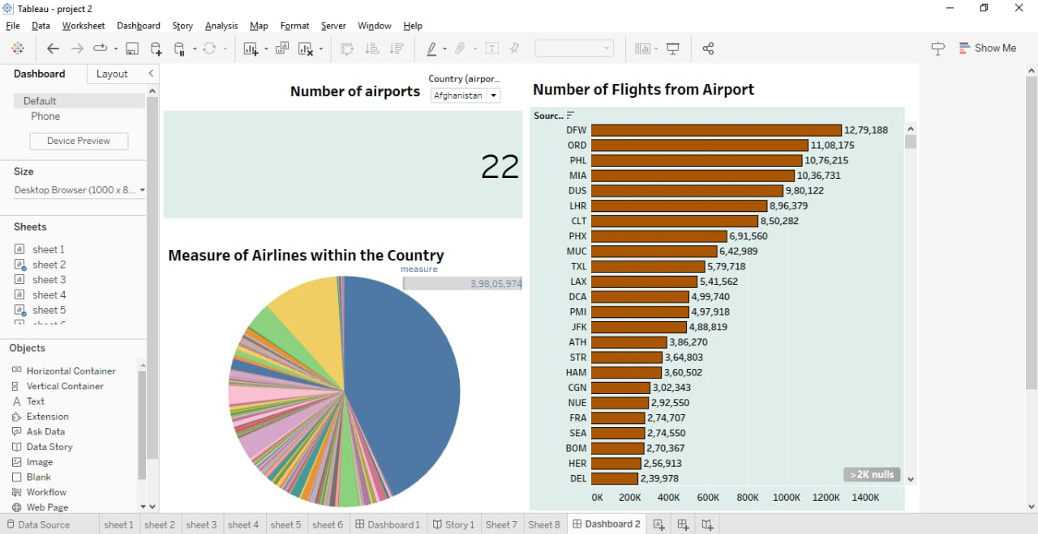**2.**

**STORY**

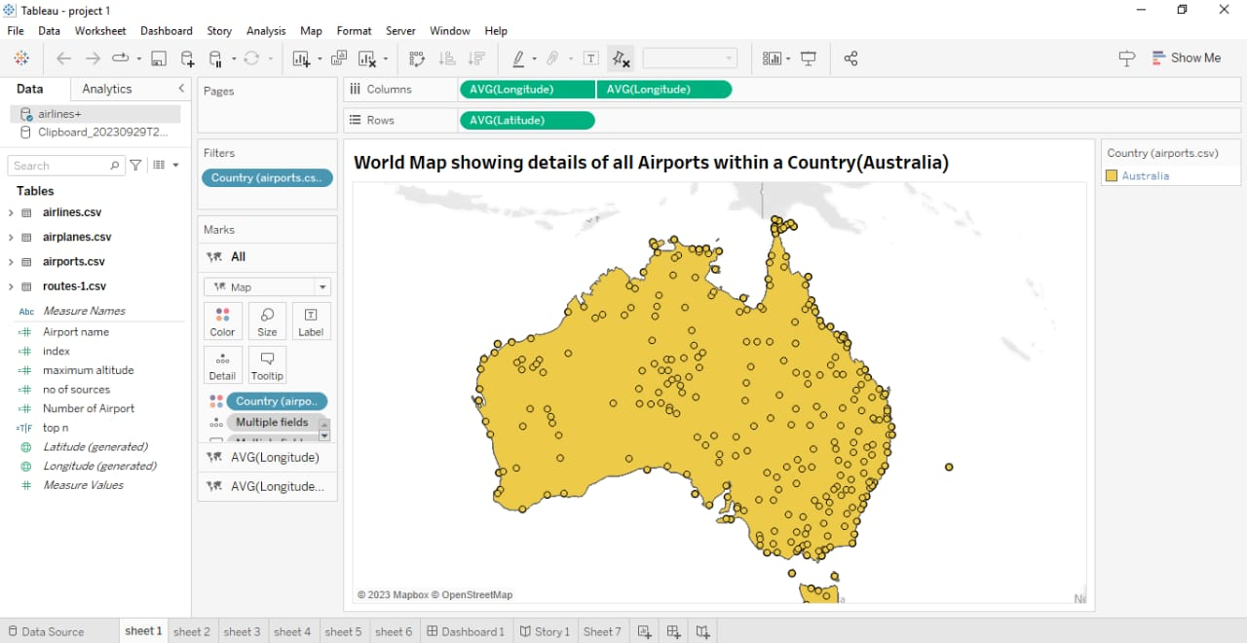

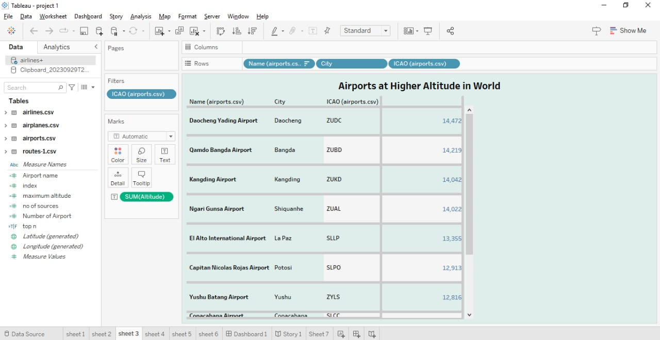

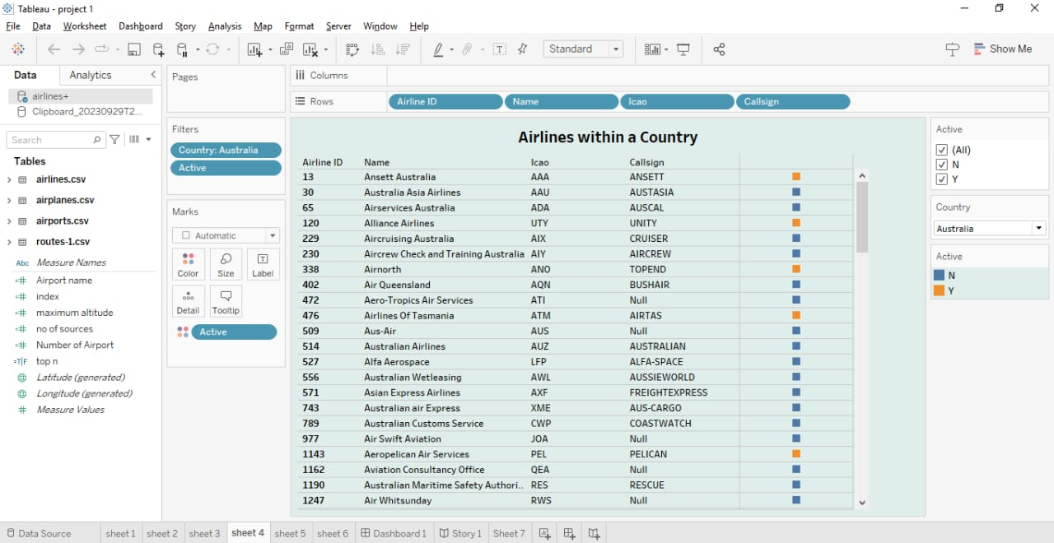

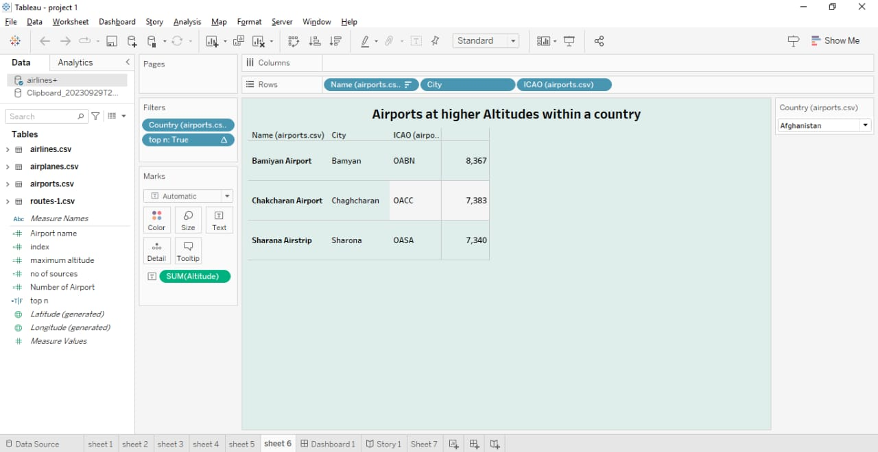

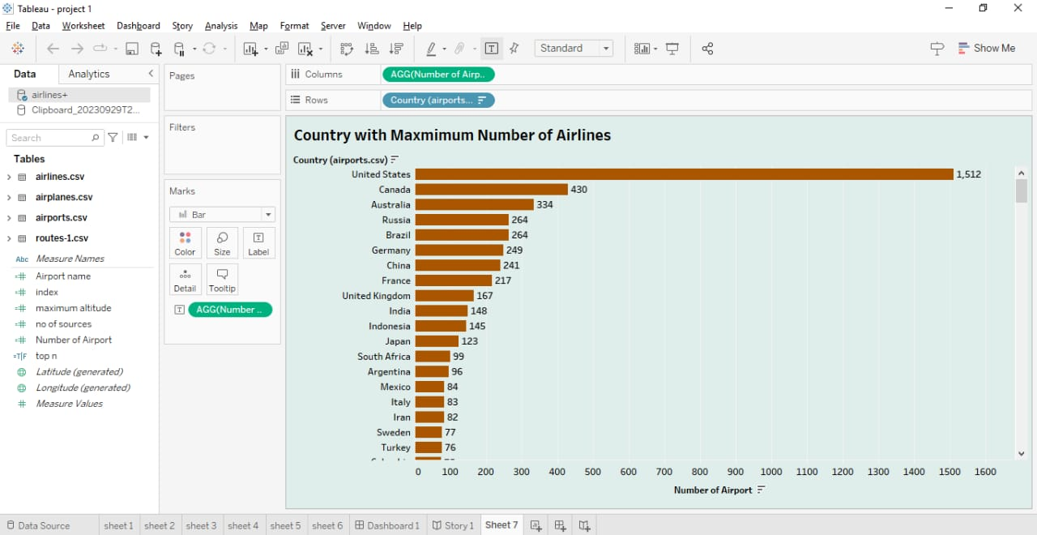



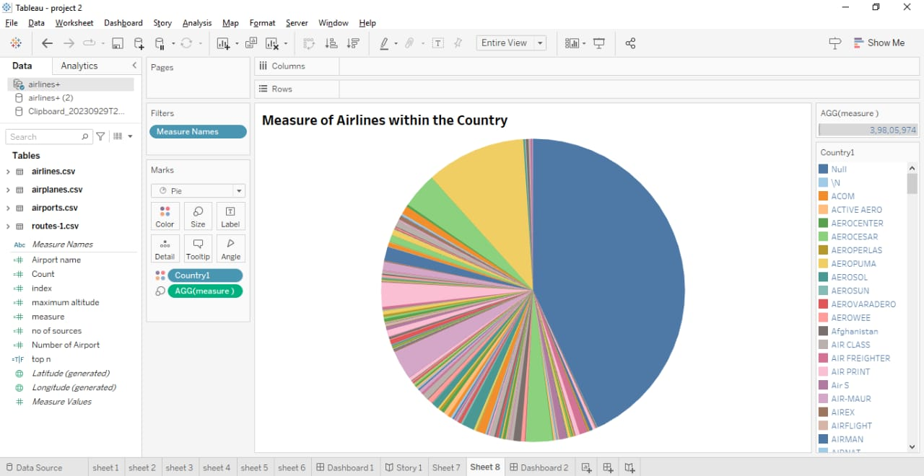

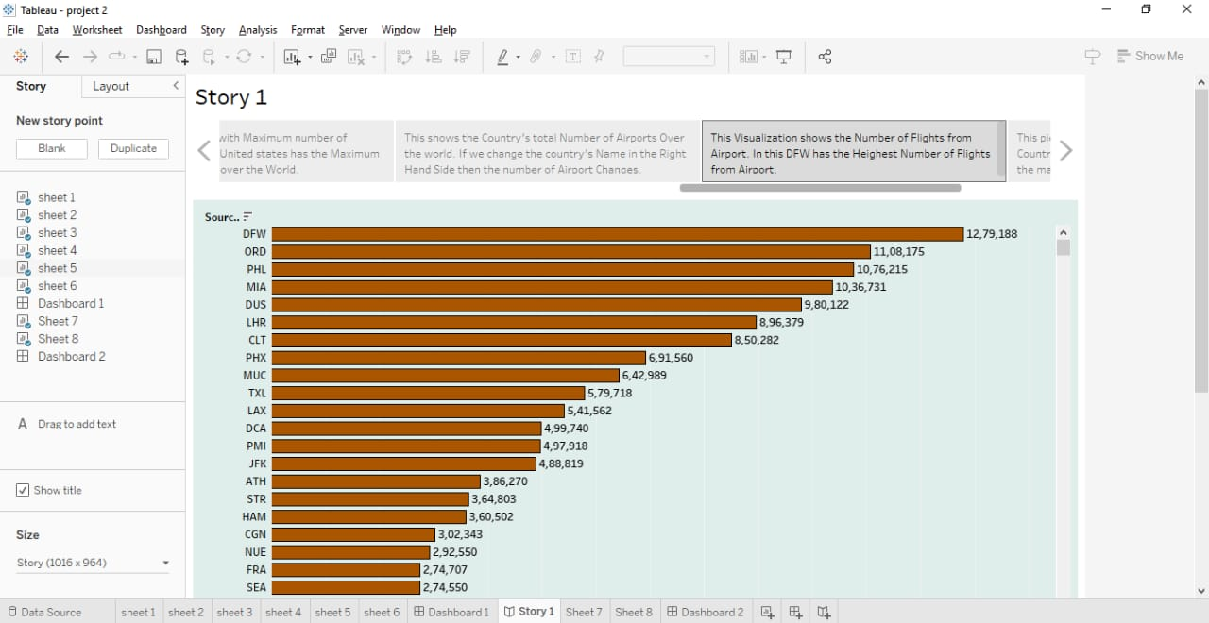

**4.ADVANDAGES & DISADVANTAGE**

**Advantages of Air Transportation Projects:**

**1. Speed:** *Air transportation is one of the fastest modes of travel, allowing for quick movement of people and goods over long distances.*

**2. Accessibility:** *Airports are located in various regions, providing access to remote or difficult-to-reach areas.*

**3. Global Connectivity:** *Air transport facilitates international trade and travel, connecting distant countries and cultures.*

**4. Efficiency:** *Large cargo planes can transport significant quantities of goods, making it efficient for transporting high-value or time-sensitive cargo.*

**5. Safety:** *Modern aircraft are equipped with advanced safety features and stringent regulations, making air travel relatively safe.*

**Disadvantages of Air Transportation Projects:**

**1. Cost:** *Air travel can be expensive, especially for long-haul flights, which may limit accessibility for some individuals and businesses.*

**2. Environmental Impact:** *Air transportation is a major contributor to greenhouse gas emissions and can have a negative impact on the environment.*

**3. Weather Dependency:** *Flights can be delayed or canceled due to adverse weather conditions, causing disruptions to travel plans.*

**4. Infrastructure Investment:** *Building and maintaining airports and air traffic control systems require significant financial investment.*

**5. Limited Capacity:** *Airports can become congested during peak travel times, leading to delays and reduced efficiency.*

**The advantages and disadvantages of air transportation projects can vary depending on factors such as location, purpose, and scale of the project.**

**5.Application**

**Absolutely! Recruitment assistants can be utilized in various applications within the field of air transportation. Here are a few examples:**

**Pilot and Crew Recruitment:** *Airlines can use recruitment assistants to streamline the hiring process for pilots, flight attendants, and ground crew. These AI systems can help screen resumes, conduct initial interviews, and assess qualifications.*

**Maintenance and Engineering Staff:** *Airlines require skilled technicians and engineers to maintain and repair aircraft. Recruitment assistants can assist in identifying qualified candidates for these critical roles.*

**Customer Service Representatives:** *Airports and airlines often need customer service representatives. AI can help in identifying individuals with strong communication skills and customer-centric attitudes.*

**Logistics and Operations:** *Air transportation involves complex logistics and operational roles. Recruitment assistants can help identify candidates with the right experience and skills for roles such as air traffic controllers, cargo handlers, and airport operations staff.*

**Security Personnel:** *Ensuring the safety and security of passengers and flights is paramount in aviation. AI can assist in screening and selecting candidates for security-related roles.*

**Management and Administrative Positions:** *Airlines and airports also require management and administrative staff. Recruitment assistants can help identify qualified candidates for positions such as airport managers, HR managers, and finance personnel.*

**In all these areas, AI-driven recruitment assistants can save time, improve the efficiency of the hiring process, and help find the best-fit candidates for various roles in the air transportation industry.**

**6.CONCLUTION**

*Air transportation is a vital component of global connectivity and commerce. It enables rapid travel over long distances, facilitates international trade, and connects people across the world. However, it also contributes to environmental challenges, such as greenhouse gas emissions. To ensure a sustainable future, the aviation industry is exploring cleaner technologies and more efficient operations. Balancing the benefits of air transportation with its environmental impact will be crucial in the years ahead.*

**7.FUTURE SCOPE**

**The future of air transportation holds several exciting possibilities:**

**Sustainable Aviation:** *There is a growing emphasis on reducing the environmental impact of air travel. This includes the development of electric and hybrid-electric aircraft, the use of sustainable aviation fuels, and advancements in aerodynamics to improve fuel efficiency.*

**Urban Air Mobility (UAM):** *UAM refers to the use of small electric vertical takeoff and landing (eVTOL) aircraft for short-distance urban transportation. It has the potential to revolutionize urban mobility and reduce congestion.*

**Supersonic Travel:** *Companies are working on supersonic and even hypersonic passenger aircraft that could significantly reduce travel times for long-haul flights.*

**Autonomous Aircraft:** *Research and development of autonomous or semi-autonomous aircraft are ongoing, which could lead to safer and more efficient flights.*

**Space Tourism:** *The commercial space industry is expanding, offering the possibility of suborbital and orbital space tourism experiences.*

**Advanced Airports:** *Airports of the future may incorporate smart technologies for smoother passenger experiences, such as biometric security checks and efficient baggage handling.*

**Drone Delivery:** *Drones are being explored for last-mile delivery of goods, medical supplies, and more.*

**Air Traffic Management:** *Advanced air traffic control systems, including the integration of artificial intelligence, will help optimize airspace usage and reduce congestion.*

**Connectivity:** *In-flight Wi-Fi and satelite -based internet connectivity will continue to improve, enhancing the passengers experience.*

**New Materials and Design:** *Innovations in materials and aircraft design will lead to lighter, more fuel-efficient aircraft.*

**These developments promise to make air transportation more efficient, sustainable, and accessible in the future.**